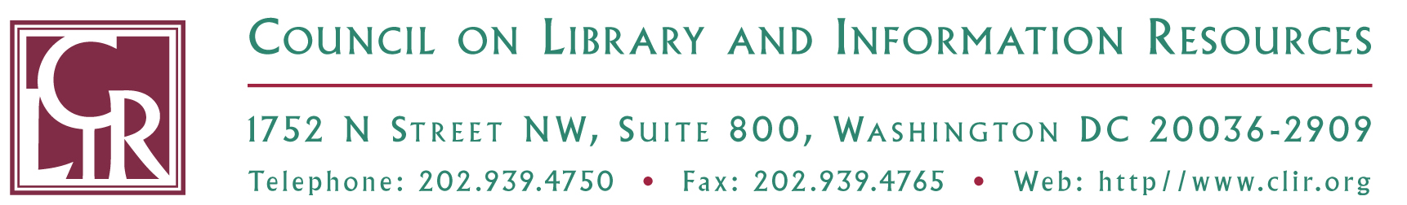

Leadership through New Communities of Knowledge

Support Statement for Application to Attend Archives for Non-Archivists Workshop at Drexel University, June 14-15, 2011

Name of Applicant:
Applicant’s Official Job Title:
Institution:

Name of Authorizing Official:
Job Title:

I affirm that I support the above-named applicant’s application to attend the Archives for Non-Archivists workshop.

Signature

Date

Save completed and signed form as a PDF and include the applicant’s name in the document title. Submit to newcommunities@clir.org by 5:00 PM EDT, April 18, 2011.

